



**Improved EECP Website Launch Project Report**

**By:** Ashley Avona, Samantha Germano, Lailumah Nadeem  
**Course:** BU MET AD642 – Project Management  
**Professor:** Anil Sawhney  
**Date:** June 17, 2025

**Contents**

Project Introduction….................................................................................................................... 3

Project Charter…............................................................................................................................ 3

Project Scope.................................................................................................................................. 5

Work Breakdown Structure............................................................................................................ 6

Network Diagram, Critical Path & Gantt Chart............................................................................. 7

Cost Estimate….............................................................................................................................. 8

Communication Management Plan…............................................................................................. 9

Risk Management…..................................................................................................................... 10

Logistics….................................................................................................................................... 11

Lessons Learned…........................................................................................................................ 12

References…................................................................................................................................. 14

Appendix………........................................................................................................................... 15

**Project Introduction**

The “Improved EECP Website Launch” project was initiated to revamp the website for Northeastern University’s External Events and Conference Programs (EECP) department. This department offers event space and summer conference housing to external clients during the university's off-peak periods. As the university seeks to enhance its reputation throughout Boston and the world as a center for lifelong learning, collaboration, and experience, it aims to attract more external groups to contribute to this mission. The primary goal of this project is to enhance communication, improve user experience, increase event inquiries and bookings, and ensure alignment with university branding and technical standards. Company websites are crucial to brand identity and are often the first impression you make on potential clients (Ciciora, 2024). Outdated information can deter potential customers and impact credibility. This report outlines the key deliverables, planning methodologies, scheduling tools, cost estimates, risk strategies, communication frameworks, and lessons learned throughout the project lifecycle.

**Project Charter**

This project was initiated by the External Events and Conference Programs (EECP) department at Northeastern University to modernize and enhance its digital presence for external clients. As the department increasingly serves organizations seeking event space and summer conference housing accommodations, it became essential to present accurate, compelling, and up-to-date information through a streamlined and professionally branded website. See Appendix A for the full project charter.

The Improved EECP Website Launch team developed a Project Charter to formally authorize the project and empower the project team to utilize university resources to achieve defined objectives. It designates Samantha Germano as the Project Manager from Northeastern University, with Ashley Avona and Lailumah Nadeem serving as Branding and IT Consultants, respectively. Together, this core team collaborates with multiple stakeholders, including the EECP department, Northeastern’s ITS and Brand Center, internal service providers, and external clients.

The charter outlines the project timeline from August 2025 to January 2026, with a fixed budget of $10,000. The project’s objectives include identifying outdated content and structural weaknesses on the current site, integrating new venue photography, aligning with Northeastern’s branding and technical guidelines, and simplifying the inquiry process for external users. Ultimately, the project aims to increase both event inquiries and bookings while also improving operational clarity for internal service providers.

Key deliverables include stakeholder requirement documentation, a complete website redesign, internal quality assurance (QA) testing, stakeholder reviews, and post-launch evaluation. The project is constrained by time (a hard deadline for the 2026 summer conference season), strict budget (university-wide budget cuts), and branding standards (university compliance). Risks such as information gaps, budget limitations, and technical feasibility were anticipated and addressed through proactive planning.

Success will be measured through increased website engagement, a reduction in user-reported submission errors, improved inquiry turnaround, and an 80% satisfaction score from post-launch surveys. This charter serves as the governing document that defines project authority, scope boundaries, and stakeholder expectations, ensuring that all project activities align with Northeastern University’s institutional goals and client service standards.

**Project Scope**

The scope of the Improved EECP Website Launch project encompasses the full planning, design, development, testing, and evaluation of a newly enhanced website for Northeastern University’s EECP department. The project is rooted in the need to better inform and engage external clients by providing them with accurate information, updated visuals, and a seamless inquiry process, all in alignment with the University’s evolving offerings and institutional standards.

The scope was defined based on stakeholder interviews, website audits, client feedback, and internal process reviews. Core deliverables include an audit of the current site, a photography campaign showcasing venues, updated and reorganized content, and a redesigned website built to meet university technical and branding compliance. This new site will address pain points such as confusing navigation, broken inquiry forms, and outdated images, to boost event inquiries and bookings.

The final website will go live by the end of December 2025, in time to serve the 2026 summer event season. A post-launch performance evaluation phase in January 2026 will assess functionality, user satisfaction, and operational success.

The scope excludes future ongoing maintenance and updates beyond the project’s January 2026 end date, which will be managed separately by EECP and university IT. Constraints include a tight timeline and a modest fixed budget of $10,000, which prioritized internal resource use and strategic task scheduling. A priority matrix guides decision-making by designating cost as the most critical constraint to manage, followed by scope and schedule. See Appendix B for more information on the priority matrix.

**Work Breakdown Structure**

The Work Breakdown Structure (WBS) was created using a top-down, deliverable-oriented approach. It decomposes the entire project scope into manageable components, ensuring full visibility into all required work. The WBS is essential for effective scheduling, budgeting, resource allocation, and risk management. The WBS consists of five main phases:

1. Analysis, Outreach & Approval – Includes internal and external stakeholder feedback collection, current website analysis, service provider interviews, and venue data collection to define project requirements.
2. Content & Media Preparation – Covers branding assets (color, font, logos), venue photography, service descriptions, and updated website content creation.
3. Website Design & Development – Focuses on architectural blueprint creation, front-end interface design (navigation, home, and venue pages), and back-end development (inquiry form, content management system (CMS) integration).
4. Testing & Launch – Includes internal QA, stakeholder testing, bug resolution, and public website launch.
5. Post-Launch Evaluation – Focuses on web performance analytics, user satisfaction surveys, and lessons learned documentation.

Each phase is broken down into work packages and sub-tasks, with clear dependencies and outputs. For example, the “Venue Photography” package includes tasks like photographer scheduling and producing setup-specific gallery images. The WBS structure allowed the team to assign resources efficiently and track progress using ProjectLibre and the Gantt chart. See Appendix D for the Work Breakdown Structure and Appendix G for the Gantt chart.

This structured approach ensured that overlapping activities, such as parallel development of content and web architecture, were accounted for and could be managed simultaneously across different team members. The WBS and its associated definition directory serve as the backbone for scheduling, cost estimation, and risk identification. It enabled full traceability of deliverables from initiation through closure and remains a key reference throughout execution. See Appendix E for the directory.

**Network Diagram, Critical Path, and Gantt Chart**

Following the creation of the Work Breakdown Structure (WBS), task dependencies and durations were analyzed to construct a network diagram. This diagram visually maps the logical sequence of project activities and was used to calculate the critical path, which represents the longest chain of dependent activities that determines the minimum duration of the project.

The critical path for the Improved EECP Website Launch project was identified as:  
Start → C → D → E → F → G → I → L → M → N → O → P → Q → R → S → T → End, totaling 27 working days. This path includes foundational tasks such as stakeholder input, technical and branding design, front-end and back-end development, integration, testing, and final review. Any delay in these tasks would result in a direct delay to the project timeline.

Non-critical activities with float were analyzed to understand areas where flexibility existed. This helped optimize resource allocation, reduce bottlenecks, and ensure timely task transitions. The network diagram also supported milestone scheduling and helped track interdependencies during the execution phase. The use of this scheduling tool was vital to meeting the deadline of December 30, 2025, especially within the constraints of university resource availability and a compressed schedule post-move-in. See Appendix F for the network diagram.

A Gantt chart was created based on the WBS and network diagram. The Gantt chart and the network diagram both show the same project schedule, just in different ways. They share the same critical path, which moves through all the major tasks from kickoff to launch and wrap-up. Tasks like CMS Implementation and Content & Media Integration play key roles in the middle of the project. The Gantt chart shows everything along a timeline which demonstrates when tasks occur and how they overlap. The network diagram focuses more on the flow of tasks and how they connect. It does a better job of showing branching points and task dependencies. The Gantt chart gives a clearer picture of durations and dates, but it can blur task relationships. Both tools are essential to the project timeline; the Gantt chart helps answer “when,” while the network diagram helps explain “how.” See Appendix G for the Gantt chart.

**Cost Estimate**

The cost estimation process was aligned with the WBS using the bottom-up estimating method, which involved assessing individual task costs and aggregating them to create an accurate overall project estimate (PMI, 2021). This approach provided greater transparency and accountability in tracking both labor and external services. See Appendix H for the cost estimate.

The total project budget was fixed at $10,000, requiring careful prioritization. Key cost categories included:

* Internal labor: Team contributions from project managers, IT specialists, marketing consultants, service providers, and venue managers
* External services: Professional photography for venue imagery and participants in the website review process (no compensation)

Given the limited and fixed budget, this project was created with consideration for external feedback provided by former clients, prospective clients, and representatives from Boston-area peer institutions, who participated in a feedback survey without compensation. This seems feasible and achievable as the EECP office regularly works with repeat clients that it has a long-standing relationship and participates in surveys of a similar nature requested by these partners.

A contingency buffer was factored in to absorb minor cost overruns, unexpected delays, or additional resource needs (e.g., last-minute design compliance adjustments). Given the limited budget, the team strategically utilized internal university services wherever possible, including leveraging Northeastern’s IT and marketing support at no additional cost aside from labor. This disciplined approach to budgeting ensured the project stayed within scope without compromising on essential deliverables. Cost tracking tools were used in parallel with the schedule to monitor burn rate and forecast final expenditures.

**Communication Management Plan**

Given the involvement of multiple departments, vendors, and end-users, a structured and inclusive communication plan was critical to project success. The team developed a communication matrix that defined:

* Who needs to receive project information (e.g., project team, sponsors, university stakeholders)
* What information is shared (e.g., progress updates, approvals, feedback)
* When communication occurs (e.g., weekly, milestone-based)
* How messages are delivered (e.g., email, Zoom meetings, documentation)
* Who is responsible for sending and receiving the information

Regular status updates were shared in weekly project meetings, while milestone approvals were scheduled with stakeholders like Northeastern’s ITS and Brand Center. A shared project folder was maintained for document control and transparency.

The communication plan promoted alignment between the technical and creative streams, minimized misunderstandings, and ensured stakeholders remained engaged throughout. It also facilitated rapid feedback loops during critical review phases such as QA testing and branding compliance checks. See Appendix C for the communication matrix.

**Risk Management**

Risk management played a central role throughout the project, especially given the limited budget and cross-departmental coordination. The team developed a detailed Risk Register that categorized potential threats and outlined mitigation strategies.

Key risks identified included:

1. Internal familiarity bias: Internal reviewers might overlook gaps that would be obvious to new or external users.  
   *Mitigation*: Incorporate feedback from external clients and industry peers for a broader perspective.
2. Form transition errors: Risk of losing inquiries during the switch to the new submission system.  
   *Mitigation*: Temporarily provide clear contact alternatives and double-test form functionality.
3. Budget shortfall: The $10,000 cap could limit full implementation.  
   *Mitigation*: Prioritize must-have features and utilize internal university support services.
4. Technical feasibility: Some desired web features might exceed in-house IT capabilities.  
   *Mitigation*: Conduct early consultations with ITS to ensure all design elements are technically achievable.

Each risk was evaluated on probability and impact and plotted in a Risk Heat Map. See Appendix I for the risk register and heat map (threats). This visualization allowed the team to focus resources on high-priority risks and build contingency into the timeline and cost estimate. While risk is often associated with negative outcomes, the positive risks of a project are additional justification for taking on a project (Kähkönen & Artto, 2000). Positive outcomes such as increased inquiries, increased bookings, and greater recognition of Northeastern as a space for external events. See Appendix J for the risk register and heat map (opportunities). This proactive approach to risk not only supported project stability but also enabled the team to respond quickly when unexpected challenges arose, thereby avoiding potential delays or scope creep.

**Logistics**

Logistics played a foundational role in ensuring the successful execution of the EECP Website Launch project. Effective logistical planning was necessary not only for resource coordination but also for meeting the strict project deadlines, especially considering university constraints such as academic calendars, space availability, and IT bandwidth.

Key logistical elements included:

* Venue Photography: Coordinating professional photoshoots of event spaces required pre-scheduling access to multiple campus locations before student move-in. This involved collaboration with facilities, scheduling teams, and photographers to capture the best visuals that reflect Northeastern’s brand and client expectations.
* Service Provider Interviews: Interviews with internal stakeholders (such as Catering, Risk Services, Housing, and Event Management) had to be scheduled to gather accurate and up-to-date content for the new site. These were aligned with internal calendars to avoid peak academic or conference periods.
* Design and IT Resource Allocation: Development and compliance reviews required IT and branding teams to oversee progress and were aligned with university standards. Coordination ensured that availability of technical staff matched critical points in the schedule, such as architecture review, branding approval, and CMS integration.
* Project Scheduling around Institutional Timelines: Tasks were strategically aligned with key institutional windows, such as pre-semester breaks or slow periods in student services, to avoid conflicts and ensure timely deliverable turnover.

Overall, the logistical approach focused on strategic alignment, clear cross-departmental coordination, and early booking of resources, allowing the team to keep momentum across concurrent work streams and avoid bottlenecks. This proactive planning helped mitigate risks associated with delays, access issues, and over-allocation of resources.

**Lessons Learned**

Reflecting on the lifecycle of the Improved EECP Website Launch project, the team identified several critical lessons that can inform future initiatives of similar scale and structure:

* Early stakeholder engagement was key: Initiating conversations with internal and external stakeholders at the outset helped shape clear objectives and functional requirements. This upfront clarity significantly reduced scope creep and minimized the need for revisions during later phases.
* Budget-conscious design encouraged creativity: Operating under a fixed $10,000 budget encouraged the team to leverage existing university resources, open-source tools, and internal partnerships. It also emphasized the importance of prioritizing “must-have” features over “nice-to-haves,” reinforcing the need for scope discipline.
* Cross-functional collaboration was both a challenge and a strength: The project depended on the cooperation of diverse university departments, each with their own timelines, review processes, and communication norms. Success was made possible through consistent communication, structured handoffs, and mutual respect across disciplines.
* Logistical synchronization was essential: Without careful coordination of design, development, content collection, and compliance reviews, the timeline would have easily slipped. Careful sequencing of work streams allowed the team to maximize productivity and maintain alignment with milestones.
* Post-launch feedback mechanisms are critical: Although ongoing maintenance is out of scope, the project team emphasized the value of building mechanisms for post-launch feedback, analytics, and user input. This ensures the site remains relevant, user-friendly, and aligned with evolving client needs and institutional priorities.

In summary, the project reinforced the importance of integrated planning, flexibility, stakeholder alignment, and metrics-driven evaluation, all of which will be applied in future university-led digital transformation projects.

**References**

Ciciora, D. (2024, September 6). Top reasons your business needs a new website. *Marcel Digital*. https://www.marceldigital.com/blog/top-reasons-your-business-needs-a-new-website

Kähkönen, K. & Artto, K. A. (2000). Balancing project risks and opportunities. Paper presented

at Project Management Institute Annual Seminars & Symposium, Houston, TX.

Newtown Square, PA: Project Management Institute.

Project Management Institute. (2021). *A Guide to the Project Management Body of Knowledge*

*(PMBOK® Guide)* (7th ed.). PMI.

**Appendix**

**Appendix A - Project Charter**

**A.** **General Information**

| ***Project Title:*** | Improved EECP Website Launch | | |
| --- | --- | --- | --- |
| ***Brief Project Description:*** | External Events and Conference Programs (EECP) is a department at Northeastern University that sells event space and housing accommodations to external organizations when they are not being used by Northeastern students, faculty, or staff. As new software, processes, regulations, and event spaces are added to EECP’s portfolio, external clients are searching for the most up-to-date information to plan their events. The new EECP website will expand and communicate important new information to its current website. | | |
| ***Prepared By:*** | Group Two - Team D: Ashley Avona, Samantha Germano, Lailumah Nadeem | | |
| ***Date:*** | May 20, 2025 | ***Version:*** | Version #2 |

**B.** **Project Objectives:**

| The New EECP Website project aims to update the existing EECP website by improving the existing website structure, adding up-to-date information, and upgrading features to better communicate service offerings. The goal of the new website is to make the inquiry process as seamless as possible for external clients and affiliates; increase event bookings and revenue; and create a resource for internal service providers.     1. Determine the outdated information and structures on the current EECP website and enhance features with modern, user-friendly action points 2. Secure updated venue photos that clearly and accurately depict the University’s offerings 3. Develop the new website in accordance with Northeastern’s marketing guidelines to promote the University’s brand 4. Complete the website launch on time and within budget 5. Capture reporting on project deliverables using pre-established performance metrics and KPIs |
| --- |

#### **C.** **Assumptions**

| 1. There is a level of confusion attributable to outdated information and photos 2. A dysfunctional submission form discourages event hosts from inquiring about availability 3. The features desired by external clients are attainable and within a modest budget 4. An appropriate budget has been established for a full, successful implementation of this project 5. Northeastern University will provide the IT and design support required for meeting University guidelines 6. Feature testing will identify the holes in the website information and inquiry process 7. Reporting metrics will be kept to track inquiry rates before and after the launch |
| --- |

#### **D.** **Project Scope**

| This project will focus on the design and implementation of a new External Events and Conference Programs website based on client feedback and internal pain points. The newly launched website will focus on clearly communicating EECP’s services and the process for booking external events on campus. This project will be completed by the start of the 2026 new year in time to promote the new site and collect inquiries for the 2026 summer conference season.    Deliverables:   1. Internal and external reviews to determine information gaps, user pain points, desired new features, and interface needs 2. Collection of service provider information and an architectural photo shoot of venues 3. Website design draft to be evaluated by Northeastern University marketing to ensure it meets the University’s branding guidelines 4. Website technical draft to be evaluated by Northeastern University IT to ensure it meets the University’s technical standards. 5. New EECP website |
| --- |

| Specifically excluded from this project is the future on-going maintenance of the EECP website to ensure it consistently provides the most updated information. |
| --- |

#### **E.** **Project Milestones**

| **Milestones** | **Deliverables** | **Date** | |
| --- | --- | --- | --- |
| **Phase #1: Analysis, Outreach & Approval** | | | |
| Kick-off meeting with University Project Representatives | General requirements, needs, and wants of all University stakeholders | August 15, 2025 | |
| Analysis of the existing EECP website | Identify information gaps and user functionality of touch-point features from an external perspective | August 20, 2025 | |
| Photography session and information collection | Produce a gallery of venue photos and gather valuable information from internal service providers. Customize both to suit external client needs without prior knowledge of University guidelines. | September 1, 2025  (prior to student move-in) | |
| Final Requirements | Use kick-off feedback, website analysis, and information gallery to generate the final website goals and get sign-off from project sponsors. | September 5, 2025 | |
| **Phase #2: Design & Development** | | | |
| Design | Brand design kit is established to outline the color schemes, fonts, logos, and website design guidelines from a brand and marketing standpoint.  Technical design plan is created, which outlines the website architecture to be built | | Brand design kit finalized: September 5, 2025 - September 12, 2024  Technical design plan created: September 13, 2025 - September 27, 2025 |
| Development | New EECP demo website completed | | Front-end and Back-end development of Demo website: September 30, 2025 - November 10, 2025 |
| Testing | Verify that website functionality meets the goals outlined in Phase One. Testing and review by internal stakeholders | | Internal Q&A + Stakeholder Testing + Bug Fixes: November 11, 2025 -December 5, 2025 |
| Launch | New EECP live website completed and launched | | December 10, 2025 - December 30 , 2025 (Final review and public launch) |
| Post-Launch | Gather performance data, feedback reports, and incident reports.  Technical web performance: Page load time, mobile responsiveness, core web vitals, server up-time  User Satisfaction: ease of navigation, streamlined inquiry process, clear representation of services  Close the project, and evaluate lessons learned. | | January 2, 2026 - January 10, 2026 (includes post-mortem with team and stakeholder review) |
|  |  |  |  |

**F. Impact Statement**

.

| **Potential Impact** | **Systems / Units Impacted** |
| --- | --- |
| May cause issues with the functionality of the current website or downtime of current inquiry form | EECP Department, IT Department, External clients |
| May increase the number of inquiries for external event rentals as a result of appealing photos and increased venue information | EECP Department, Internal Service Providers, Student groups (limited access to space) |
| May increase revenues for the University as a result of increased event bookings | EECP Department, Internal Service Providers, University Leadership |

**G.** **Roles and Responsibilities**

| **Executive Sponsor** | | |
| --- | --- | --- |
| **Name** | **Role** | |
| Jeremy Reger | Director of Event Management | |
| **Project Manager** | | |
| **Name** | **Area** | |
| Samantha Germano | AD, External Events | |
| Lailumah Nadeem | IT Specialist and Consultant | |
| Ashley Avona | Branding & Marketing Specialist and Consultant | |
| **Project Team Members** | | |
| **Name** | **Role** | |
| Kaitlyn Donovan | Director, Business Operations | |
| Eden Filter | AD, Conference Housing | |
| Sherley Jean-Gilles | AD, Intern Housing | |
| DJ Fikru | Technical Systems Manager, Student Affairs | |
| **Stakeholders** | | |
| **Name** | **Role** | |
| Madeleine Estabrook | Senior Vice Chancellor of Student Life | |
| EECP | External Event Sales and Management | |
| Northeastern ITS | IT Department | |
| Northeastern Brand Center | University Branding and Marketing | |
| External Event Clients | Clientele | |
| Northeastern Advancement | Event Venue Manager | |
| Planning, Real Estate, and Facilities | Event Venue Manager, Internal Service Provider | |
| Event Management | Event Venue Manager, Internal Service Provider | |
| Center for Student Involvement | Internal Service Provider | |
| Northeastern Catering | Internal Service Provider | |
| Northeastern Risk Services | Internal Service Provider | |

**H.** **Resources**

| **Resource** | **Constraints** |
| --- | --- |
| **Project Budget** | $10,000.00 |
| **Timing** | August 2025 – January 2026 |

**I.** **Project Risks**

| **Risk** | **Mitigation Strategy** |
| --- | --- |
| Internal reviews may not be able to catch all information gaps, as they are familiar with the process of planning an on-campus event | Solicit feedback from external clients on what they would like to see on the new website.  Connect with industry peers to ask for their assistance reviewing the original website with a mixed view: external yet familiar.  Gather data from pre-launch inquiries to see the most common questions from external clients |
| Inquiries may be lost during the transition from the original form to the new form | Temporarily update website with clear instructions on how to contact the EECP staff via email |
| Limited budget compromising full implementation of new website goals | Strategically allocate budget for services that cannot be completed using University resources |
| Desired technical architecture may be too complicated to implement by the in-house IT Team | Establish feasibility with the IT Team prior to planning features so that the best plan can be created using available resources |

**J.** **Success Measurements**

| **Metrics** | **How Measured?** |
| --- | --- |
| **Accurately depict external event services** | Internal review by service providers and venue managers to validate that service offerings are accurate and realistically reflect capabilities |
| **Increased event inquiries** | Compare pre-launch vs post-launch inquiries |
| **Increased event bookings** | Create pre-launch bookings vs post-launch bookings |
| **Properly performing website functions and submission forms** | Error and bug logs  Tracking the number of emails about inquiry challenges pre-launch vs post-launch |
| **80% user approval rating on website design and inquiry process** | Post-launch user surveys analysis |

**K.** **Approvals**

| **Stakeholders** | | |
| --- | --- | --- |
| **Name** | **Signature** | **Date** |
| Madeleine Estabrook |  |  |
| **Executive Sponsor** | | |
| **Name** | **Signature** | **Date** |
| Jeremy Reger |  |  |
| **Project Manager** | | |
| **Name** | **Signature** | **Date** |
| Ashley Avona |  |  |
| Samantha Germano |  |  |
| Lailumah Nadeem |  |  |

**Appendix B – Priority Matrix :**

|  | **Constrain** | **Enhance** | **Accept** |
| --- | --- | --- | --- |
| **Scope** |  | **x** |  |
| **Time** |  |  | **x** |
| **Cost** | **x** |  |  |
|  | | | |
| **Constrain** | **Project specific:**  The project must stay within the allocated $10,000 budget. Any cost overruns are not permitted due to strict financial limitations. | | |
| **Enhance** | **Project specific:**  The project aims to deliver as many value-adding features and improvements as possible, as long as they fit within the approved budget. | | |
| **Accept** | **Project specific:**  While there is a preferred timeline to meet seasonal goals (launch by the end of 2025), the schedule allows for slight flexibility if needed to ensure quality. | | |

**Appendix C – Communication Matrix**

| Communication Type | Purpose | Medium | Audience | Frequency | Owner | Deliverables |
| --- | --- | --- | --- | --- | --- | --- |
| Project Kick-off Meeting | Align expectations; define goals; outline scope and timeline | Zoom | Project Team; EECP; IT; Brand Center; Service Providers; Venue Managers | One-time (Aug 15, 2025) | Project Manager (Samantha Germano) | Agenda, Meeting minutes |
| Weekly Project Status Updates | Track progress, identify roadblocks, assign next action steps | Zoom | Project Team; EECP | Weekly (Mondays) | Project Manager | Shared Google folder; Recap email for next steps |
| Stakeholder Check-ins | Share milestone updates, request approvals | Email | EECP; ITS; Brand Center; Venue Managers; Service Providers; Project Sponsor | Key Milestones | Project Manager | Milestone summary report |
| Design Review Sessions | Present and refine design drafts | Zoom | Brand Center | Bi-weekly (Sep–Oct) | Branding Consultant (Ashley Avona) | Branding kit |
| Technical Review Meetings | Validate technical feasibility, back-end integration | Zoom | ITS Team | Bi-weekly (Sep–Oct) | IT Consultant (Lailumah Nadeem) | Technical feasibility checklist/report |
| Content Sync Meetings | Align content updates with site structure | Zoom | ITS; Branding Center; Project team | As needed (Aug–Oct) | Branding Consultant | Updated content map/alignment checklist |
| QA & Testing Feedback Loops | Capture and address issues before launch | Email | Internal Team, Stakeholders | Daily during testing (Nov) | QA Lead / Project Manager | Bug tracker |
| Launch Announcement | Notify all stakeholders and users of launch | Email, Newsletter | University Community, External Clients | One-time (Dec 2025) | EECP Team | Marketing email; banner to include in email signatures |
| Post-launch Survey & Metrics Report | Collect feedback and performance data | Google Form | Website users, EECP, Project Team, Project Sponsor | One-time (Jan 2026) | IT Consultant (Lailumah) / Branding Consultant | Google Forms report PDF |
| Project Closure Review | Evaluate lessons learned, finalize documentation | Zoom | Project Team, Sponsors | One-time (Jan 2026) | Project Manager | Final report |

**Appendix D – Work Breakdown Structure (WBS):**

| **WBS Code** | **Task Name** |
| --- | --- |
| 1 | Analysis, Outreach & Approval |
| 1.1 | Internal Stakeholder Requirements Summary |
| 1.2 | External Stakeholder Feedback Report |
| 1.3 | Existing Website Audit |
| 1.4 | Information Gap Analysis |
| 1.5 | Service Provider Interviews Summary |
| 1.6 | External Client Feedback Report |
| 1.7 | Venue Data Collection |
| 1.7.1 | Most Requested Venues Report |
| 1.7.2 | Venue Capacity Matrix |
| 1.7.3 | Setup Configuration Summary |
| 1.7.4 | Availability Calendar |
| 1.8 | Final Requirements Document |
| 1.9 | Sponsor Approval Form |
| 2 | Content & Media Preparation |
| 2.1 | Brand Design Kit |
| 2.1.1 | Color Scheme |
| 2.1.2 | Font Set |
| 2.1.3 | Logo Assets |
| 2.2 | Venue Photography |
| 2.2.1 | Photographer Scheduling |
| 2.2.2 | Venue Photo Gallery (with common setup) |
| 2.3 | Service Provider Information Packet |
| 2.4 | Updated Website Content |
| 2.4.1 | Service Descriptions |
| 2.4.2 | Inquiry Submission Instructions |
| 2.5 | Branding and Compliance Review Submission |
| 3 | Website Design & Development |
| 3.1 | Website Architecture Blueprint |
| 3.2 | Front-End Interface |
| 3.2.1 | Navigation System |
| 3.2.2 | Home Page |
| 3.2.3 | Venue Details Page |
| 3.2.4 | Inquiry Form Page |
| 3.3 | Back-End Functionality |

| 3.3.1 | Submission Form Integration |
| --- | --- |
| 3.3.2 | CMS Implementation |
| 3.4 | Content & Media Integration |
| 3.5 | Internal Design Review (IT & Marketing) |
| 4 | Testing & Launch |
| 4.1 | Internal Quality Assurance Report |
| 4.2 | Stakeholder Testing Summary |
| 4.3 | Bug & Issue Log |
| 4.4 | Final Review & Approval |
| 4.5 | Public Website Launch |
| 5 | Post-Launch Evaluation |
| 5.1 | Website Performance Report |
| 5.1.1 | Site Traffic Analytics |
| 5.1.2 | Page Load Time Report |
| 5.1.3 | Mobile Responsiveness Test |
| 5.1.4 | Core Web Vitals Score |
| 5.2 | User Satisfaction Survey Results |
| 5.3 | Final Project Report |
| 5.4 | Lessons Learned Summary |

**Appendix E - Network Diagram Directory**

| **ID** | **Task Name** | **Duration (days)** |
| --- | --- | --- |
| A | Internal Stakeholder Requirements Summary | 3 |
| B | External Stakeholder Feedback Report | 3 |
| C | Existing Website Audit | 2 |
| D | Information Gap Analysis | 2 |
| E | Final Requirements Document | 2 |
| F | Brand Design Kit | 4 |
| G | Venue Photography | 3 |
| H | Service Provider Info Packet | 2 |
| I | Updated Website Content | 3 |
| J | Website Architecture Blueprint | 4 |
| K | Front-End Interface | 5 |
| L | Back-End Functionality | 5 |
| M | Content & Media Integration | 1 |
| N | Internal Design Review | 1 |
| O | Internal Quality Assurance | 2 |
| P | Stakeholder Testing | 2 |
| Q | Bug Fixes | 2 |
| R | Final Review & Approval | 1 |
| S | Public Launch | 1 |
| T | Post-Launch Evaluation | 4 |

**Appendix F - Network Diagram**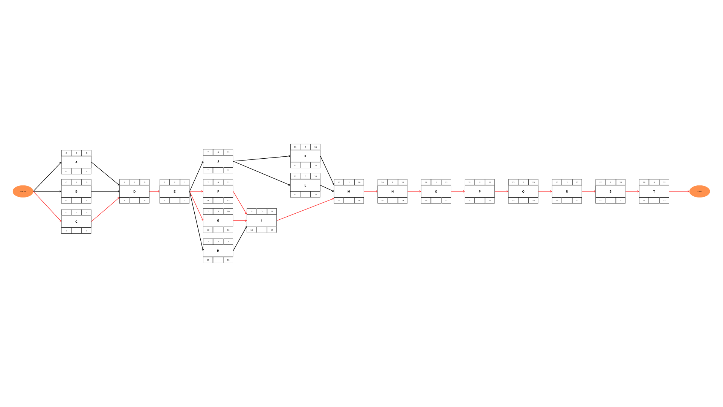

**Appendix G - Gantt Chart**

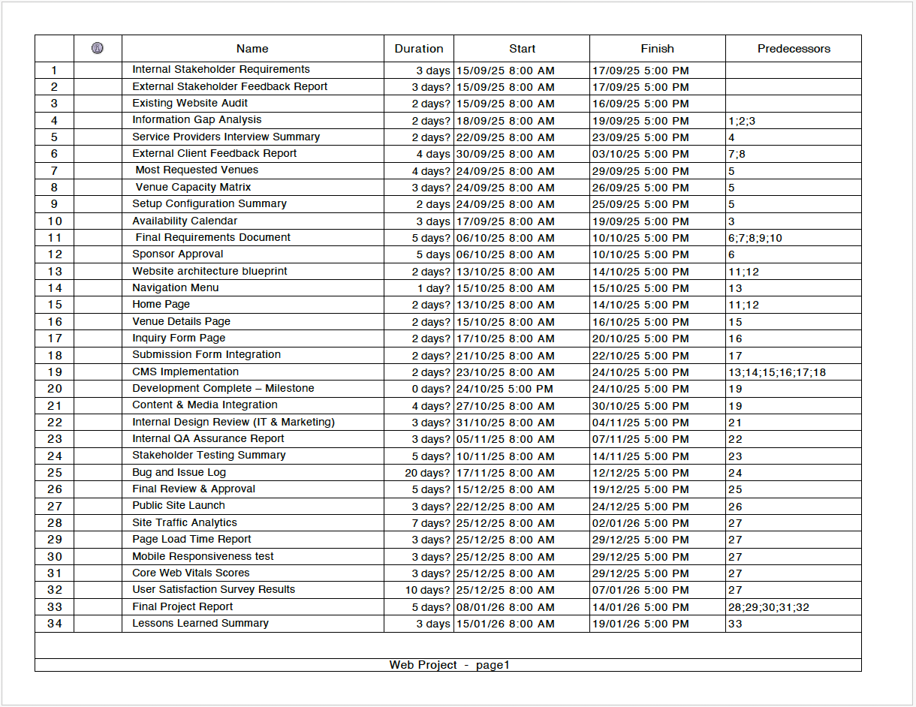

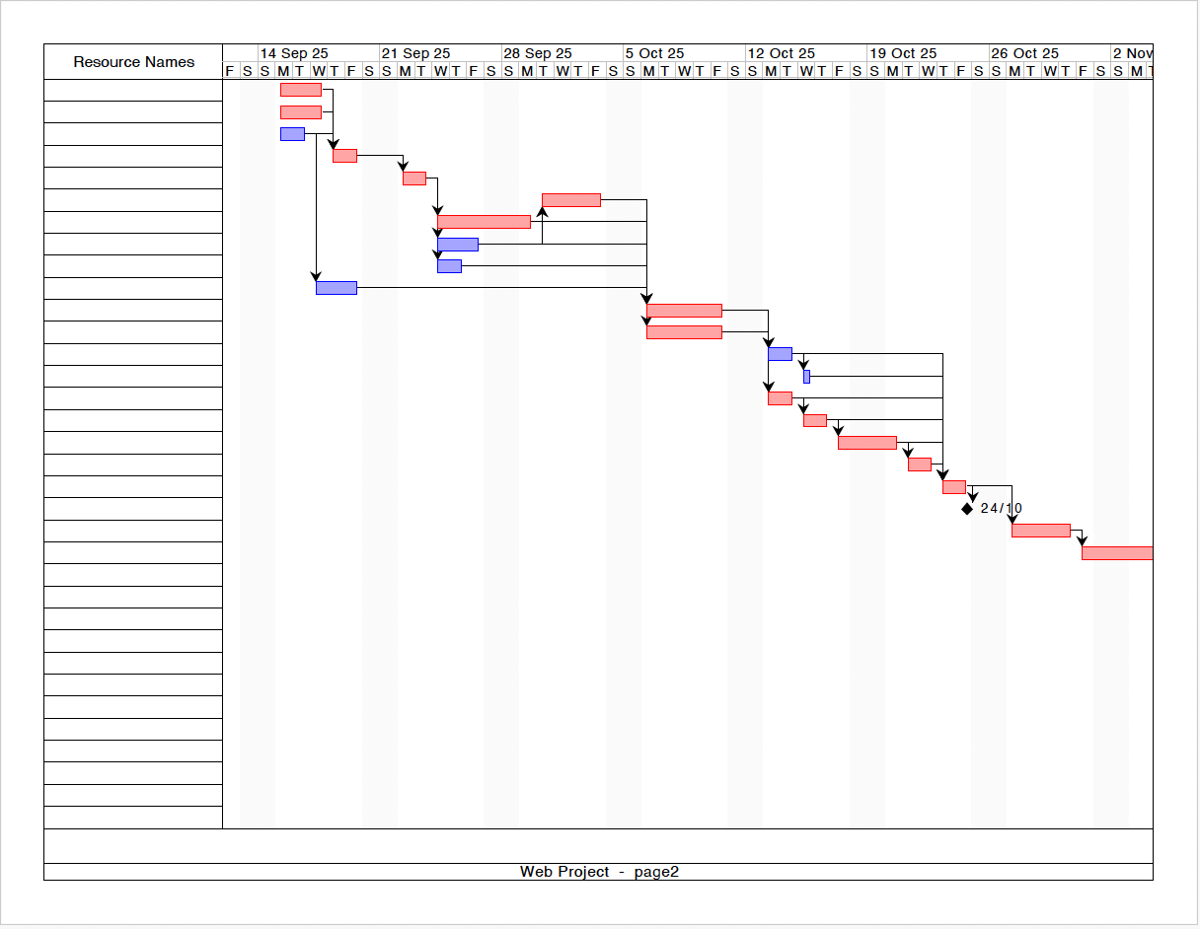

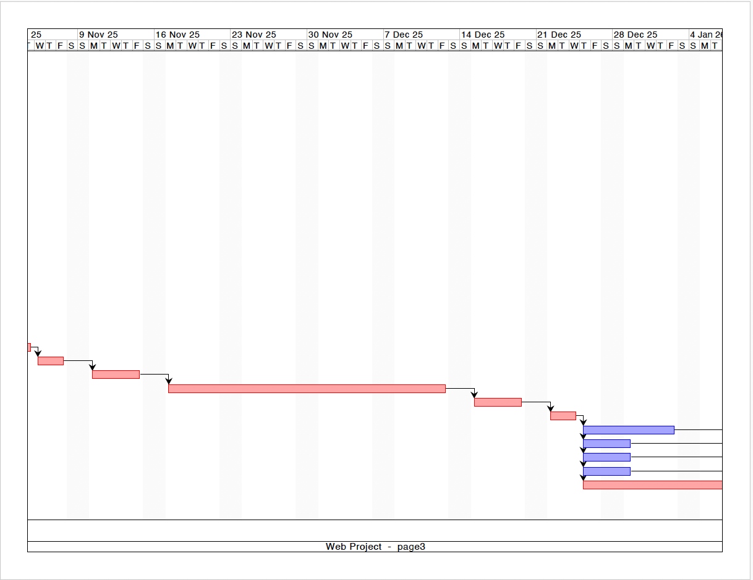

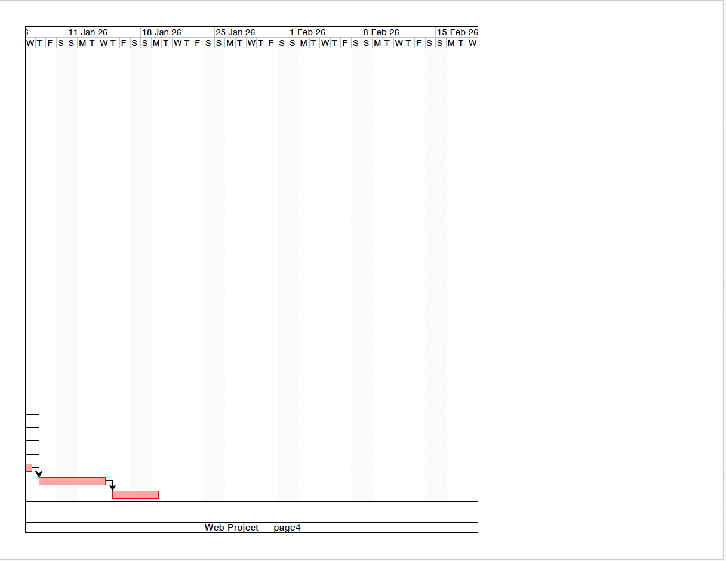

**Appendix H – Cost Estimate (Bottom-up Approach) :**

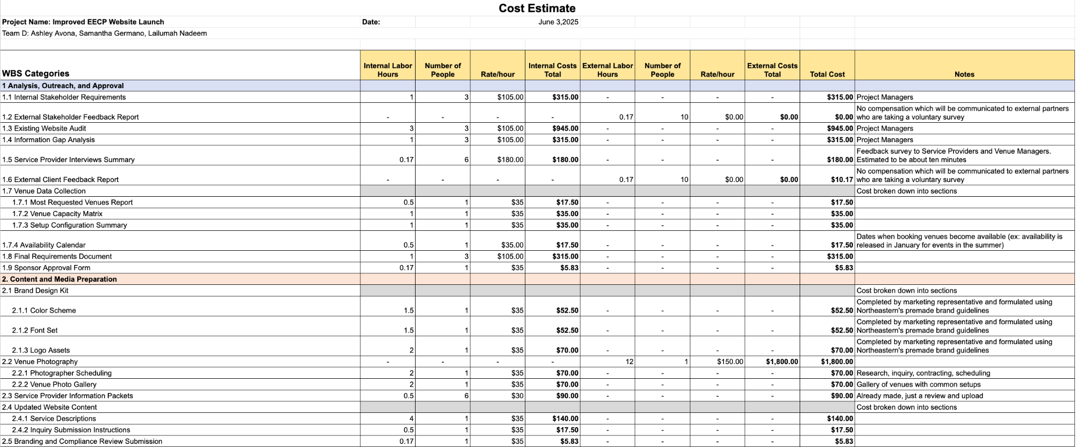

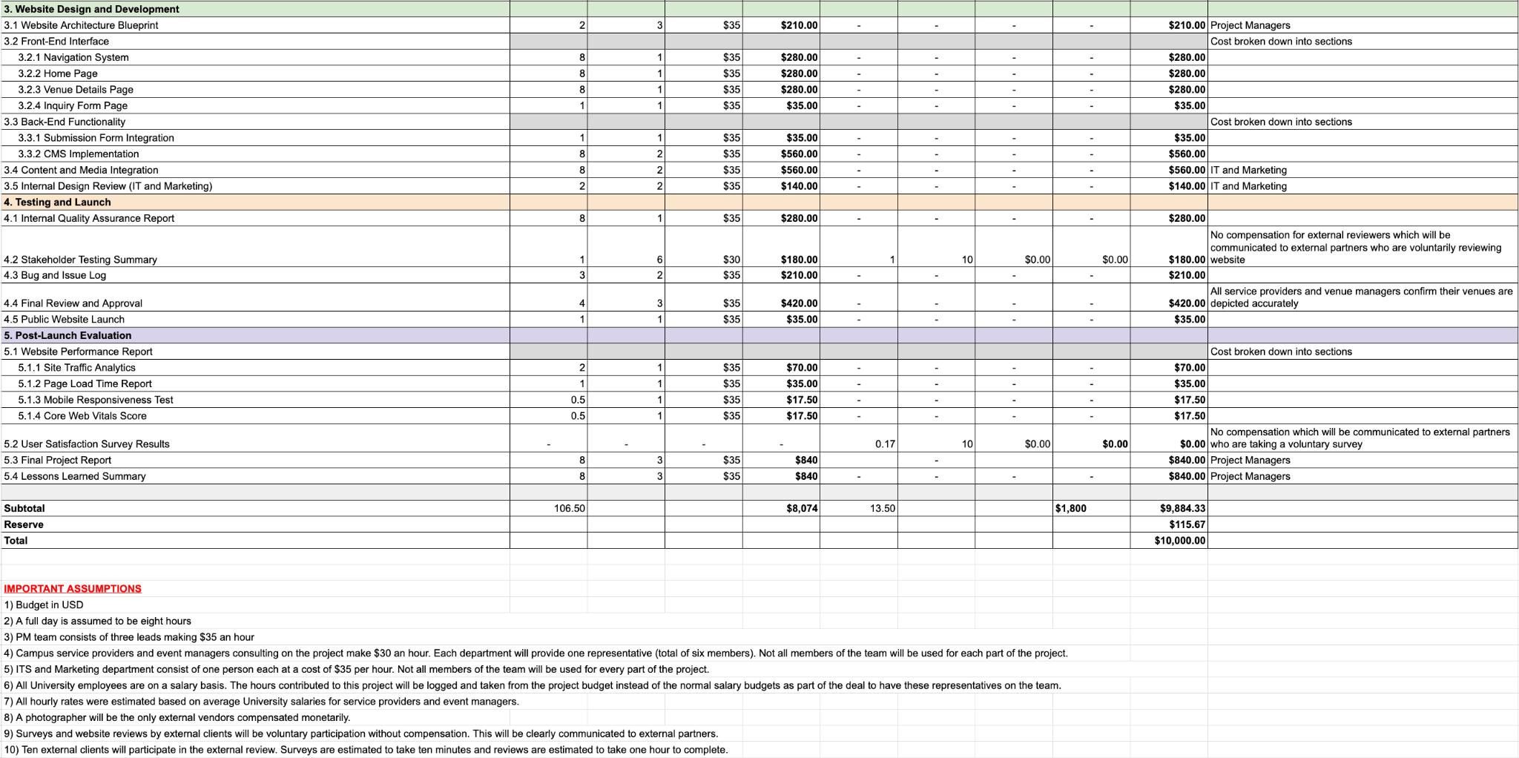

**Appendix I – Risk Register & Heat Map (Threats):**

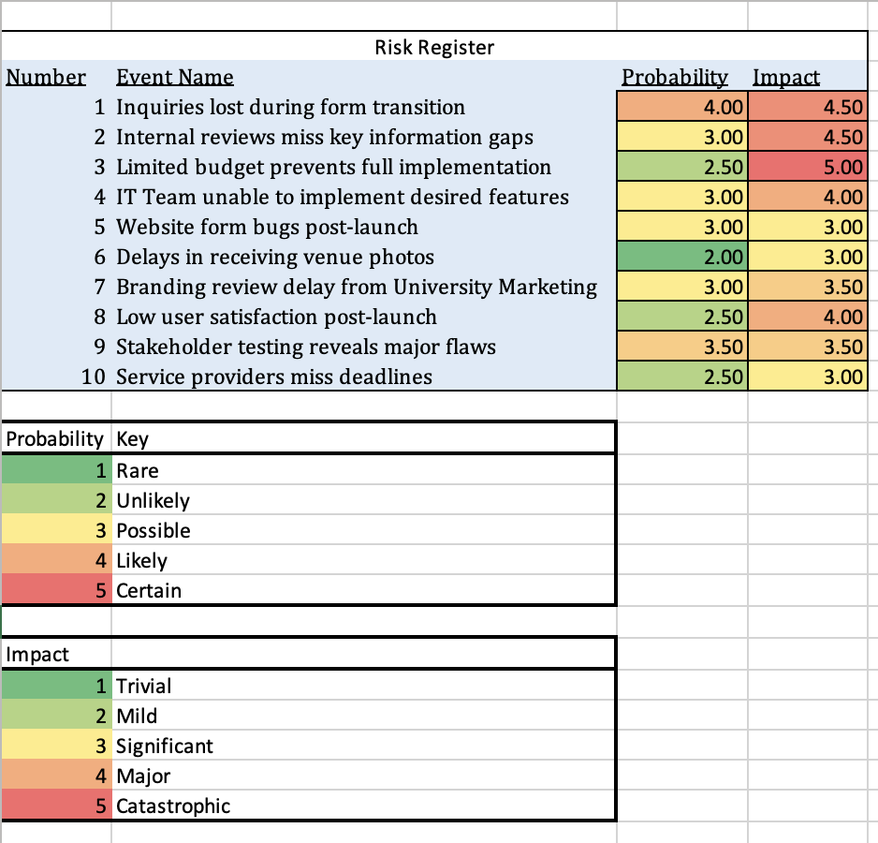

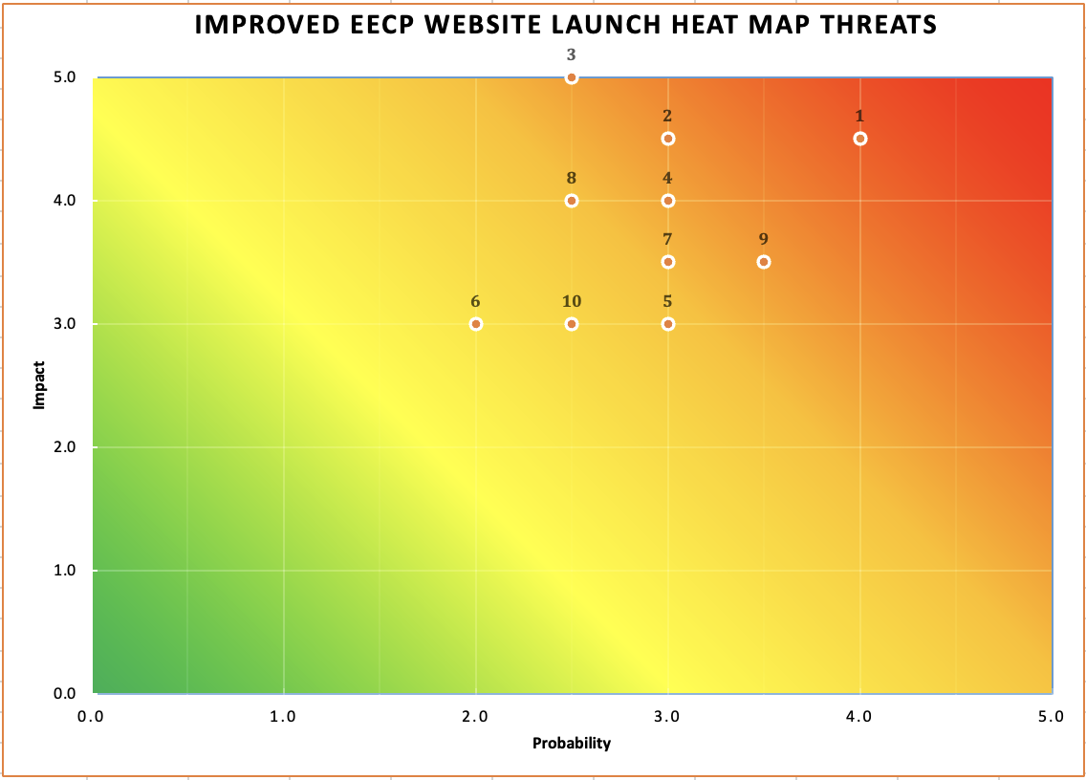

**Appendix J - Risk Register & Heat Map (Opportunities):**

